**Expiriment NO: 8**

**Aim : Familiarisation of linux commands**

**CO2 : Perform system administration task**

procedure :

**1)ip aadr**

To see the ip address.

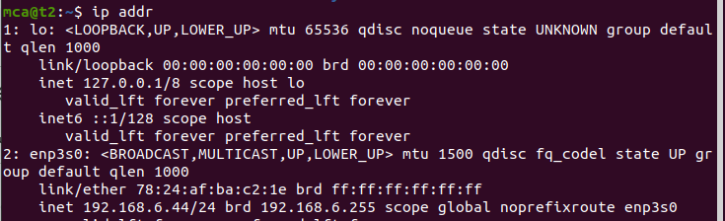

**2) ssh username@ip address**

ssh stands for secure shell protocol,used to securly connect to a remote server or system.ssh is secured in sense,it transfers data in encrypted form between host and client.

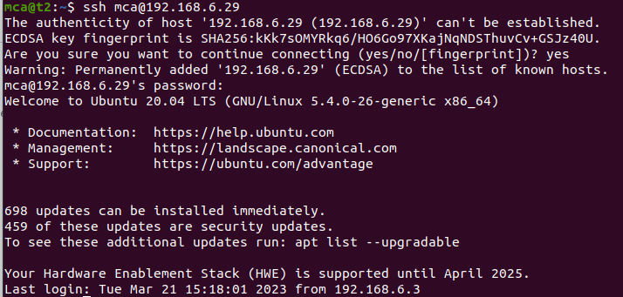

**3)sudo ufw allow port number**

To allow access to a port number

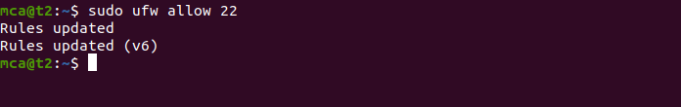

**4)ssh-keygen**

used to create ssh key.

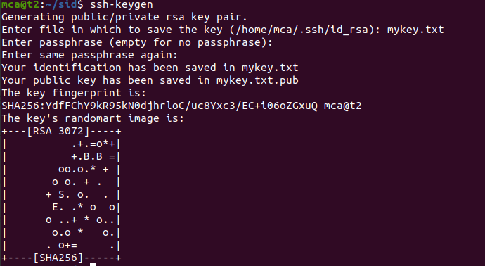

**5)ps**

ps is used to show currently executing process.

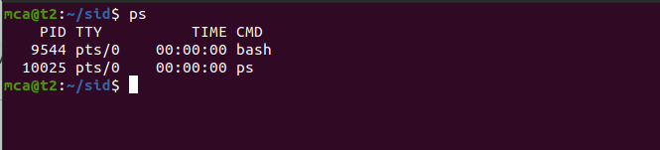

**5.1)ps -u username**

Number of currently processes of a user.

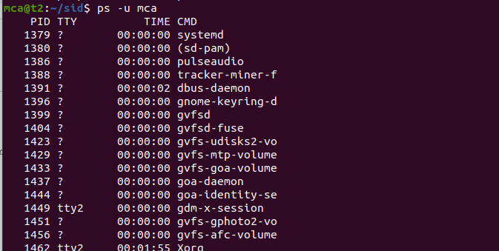

**5.2)ps -c application name**

shows id of specified application.



**5.3)ps -f -p processid**

To display user informations.

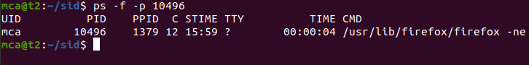

**8)compgen -g**

Used to display all the groups.

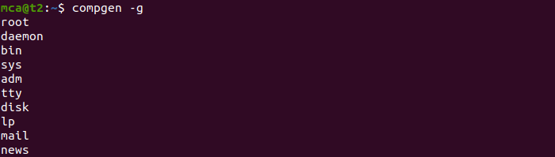

**9) chmod -wx filename**

chmod is used to change the access permissions of files and directories,it stands for change mode.

read(r)

write(w)

execute(x)

denying the permissions

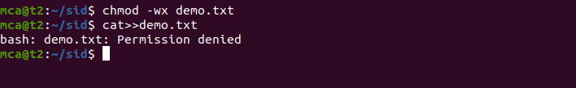

allowing permissions

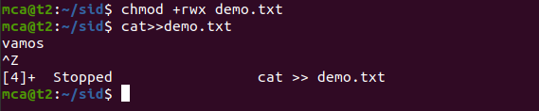

**10)sudo chown username filename**

To change the file or directory ownership for a user or a group,chown stands for change owner.

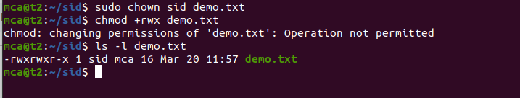

**11)sudo userdel username**

Used to delete user.

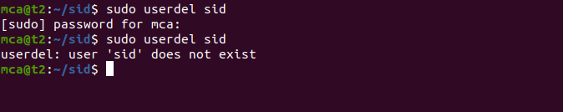

**12)sudo groupdel groupname**

Used to delete groups.

